**USE CASE**

@startuml

left to right direction

skinparam usecase {

BackgroundColor DarkSeaGreen

BorderColor DarkSlateGray

BackgroundColor<< Main >> YellowGreen

BorderColor<< Main >> YellowGreen

ArrowColor Olive

ActorBorderColor black

ActorFontName Courier

ActorBackgroundColor<< Human >> Gold

}

package Blog {

usecase "login" as UC6

usecase "addArtcle" as UC7

usecase "addPhoto" as UC11

usecase "addComment" as UC8

usecase "Delete" as UC9

}

user --> UC6

user --> UC7

user --> UC8

user --> UC9

user .> UC11

package blogOwner {

usecase "login" as UC1

usecase "DeleteUser" as UC4

usecase "DeletArticlesOfOthers" as UC5

}

admin --> UC1

admin --> UC4

admin --> UC5

@enduml

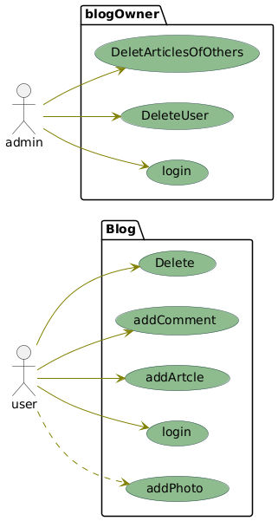

**CLASS**

@startuml

class User

{

+nom: string

+email: string

+signup()

+selectContent()

}

User -- Article : "1..1"

class Article

{

+nom: string

+texte: string

+createContent()

+readContent()

+updateContent()

+deleteContent()

}

User -- Comment : "1..1"

class Comment

{

+nom: string

+texte: string

+createContent()

+readContent()

+updateContent()

+deleteContent()

}

Article .> addPhotos

User <|-- Admin

class Admin

{

+nom: string

+email: string

+deleteOthersContent()

}

@enduml

